Section 1: Case Summary

Scenario Title:
Keywords: | Left ventricular assist device (LVAD), pump thrombosis, cardiology, cardiothoracic surgery
Brief Description of Case: | A 70 y/o male post LVAD implantation presents to the emergency department with a chief complaint of shortness of the breath. The team will need to progress through the initial assessment of an LVAD patient, ultimately leading to a diagnosis of pump thrombosis. They will initiate anticoagulation, consult cardiothoracic surgery, and admit to CTICU.

Goals and Objectives
Educational Goal: | Increase awareness and knowledge of LVADs and potential complications that may present to the emergency department
Objectives:  (Medical and CRM) | 1. Perform a focused history and physical exam for the LVAD patient  2. Demonstrate proper technique for BP/MAP measurement in an LVAD patient  3. Demonstrate proper inspection of external components of an LVAD device  4. Initiate the work up to assess for a potential LVAD-related complication  5. Clinically recognize and treat LVAD pump thrombosis
EPAs Assessed: | N/A

Learners, Setting and Personnel
Target Learners: | ☐ Junior Learners |  | ☒ Senior Learners |  |  | ☐ Staff
 | ☒ Physicians | ☐ Nurses |  | ☐ RTs | ☐ Inter-professional
 | ☐ Other Learners:
Location: | ☒ Sim Lab |  | ☐ In Situ |  |  | ☐ Other:
Recommended Number of Facilitators: | Instructors: 1
 | Sim Actors: 1
 | Sim Techs: 1

Scenario Development
Date of Development: | May 13th, 2022
Scenario Developer(s): | Christopher Ding, Jane Kim, Jessica Stetz, Sigrid Wolfram
Affiliations/Institutions(s): | Kings County Hospital Center
Contact E-mail: | chrisding2012@gmail.com
Last Revision Date: | May 13th, 2022
Revised By: | Christopher Ding
Version Number: | 1

Section 2A: Initial Patient Information

- Patient Chart
Patient Name: Horatio |  |  |  | Age: 70yo | Gender: M | Weight: 64kg
Presenting complaint: Shortness of breath
Temp: 96.8°F/36.6°C | HR:101 | BP: N/A |  | RR: 21 | O₂Sat: 92% | FiO₂: R/A
Cap glucose: 5.1 mmol/L |  |  |  | GCS: 15 (E4 V5 M6 )
Triage note: 70 y/o male with CHF, an ICD, and an LVAD presents with 3 days of shortness of breath on exertion and bilateral leg swelling.

Allergies: NKDA
Past Medical History:  CHF: ICD placed 3 years ago, LVAD 1 year ago  Diabetes: on insulin  HTN, dyslipidemia, GERD, BPH |  |  | Current Medications:  Aspirin, warfarin, sacubitril/valsartan, metoprolol, insulin, atorvastatin, tamsulosin

Section 2B: Extra Patient Information

A. Further History
Include any relevant history not included in triage note above. What information will only be given to learners if they ask? Who will provide this information (mannequin’s voice, sim actors, SP, etc.)?

Mannequin:
- Progressively worsening shortness of breath, orthopnea, bilateral LE edema x3 days. Urine appears darker than usual.
- Denies fevers, chills, cough, hemoptysis, sore throat, chest pain, recent travel, dysuria, flank pain, frequency
- Last surgery was LVAD implantation 1 year ago, performed by CT surgery at present hospital
B. Physical Exam
List any pertinent positive and negative findings
Cardio: Mechanical whirring sounds. | Neuro: AOx3, no neuro deficits
Resp: Speaking in full sentences, mildly tachypneic at rest, bibasilar crackles on auscultation. | Head & Neck: Icteric conjunctivae.
Abdo: Soft, non-tender, no masses. Drive line exiting wall of right upper quadrant, no induration or erythema. | MSK/skin: No rashes or jaundice.
Other: 2+ pitting edema to bilateral LE up to calves, symmetric in diameter. Non-palpable pulses throughout.
Device Inspection: Heartmate II LVAD. Drive line and connecting lines connected to system controller, each connecting line connected to battery on each strap of carrier bag. Battery full, no system alerts. Parameters are speed 8600, power 10, pulsatility index 4.0, and flow 2.5 L/min.

Section 3: Technical Requirements/Room Vision

A. Patient
☒ Mannequin (specify type and whether infant/child/adult)
☐ Standardized Patient
☐ Task Trainer
☐ Hybrid
B. Special Equipment Required
- Ideally, an old or unused LVAD controller, battery, lines, and battery pack, if available
- Alternatively, images of the HeartMate II controller interface and batteries can be found online, printed, and glued to small cardboard boxes to simulate external parts of an LVAD
- A backpack and rope/wiring can be used to build the rest of the external components of the LVAD

C. Required Medications
- Heparin

D. Moulage
- Hospital gown
- IV in place

E. Monitors at Case Onset
☐ Patient on monitor with vitals displayed
☒ Patient not yet on monitor
F. Patient Reactions and Exam
Include any relevant physical exam findings that require mannequin programming or cues from patient
(e.g. – abnormal breath sounds, moaning when RUQ palpated, etc.) May be helpful to frame in ABCDE format.
- Increased respiratory rate
- No heart sounds. “Whirring” sound if programmable
- Pulses non-palpable throughout

Section 4: Sim Actor and Standardized Patients

Sim Actor and Standardized Patient Roles and Scripts
Role | Description of role, expected behavior, and key moments to intervene/prompt learners. Include any script required (including conveying patient information if patient is unable)
Bedside RN | - Will notify team of the patient’s arrival in the ER  - Will ask team which labs should be drawn  - If team is struggling, will say they have worked with the LVAD team in the ED before
LVAD Coordinator | - Will walk team through inspection of the LVAD device and parameters  - Will suggest CT surgery consultation for interpretation of labs and parameters if needed

Section 5: Scenario Progression

Scenario States, Modifiers and Triggers
Patient State/Vitals | Patient Status | Learner Actions, Modifiers & Triggers to Move to Next State |  | Facilitator Notes
1. Baseline State  Rhythm: NSR  HR: 101  BP: n/a  RR: 21  O₂SAT: 92%  T: 36.6ºC  GCS: 15 | Patient is alert, speaking in full sentences, but becomes mildly tachypneic with prolonged speech | Expected Learner Actions  Provide supplemental O2  Place patient on cardiac monitor  Obtain MAP by utilizing bedside or ultrasound doppler (see appendix C) | Modifiers  - 2L NC O2 given O2 sat 96%  Triggers  - Measures MAP 2. Initial Evaluation | - If the team is struggling, nurse/instructor may state “I think we have an LVAD team at our hospital who can help”
2. Initial Evaluation  Rhythm: NSR  HR: 101  MAP: 63mmHg  RR: 15  O₂SAT: 96% on 2L NC  T: 36.6ºC  GCS: 15 | Patient is alert, speaking in full sentences. Endorses improvement in dyspnea. | Expected Learner Actions  Perform history and exam  Discuss differential management plan amongst team members  Inspect LVAD lines and controller (see appendix C)  Order EKG, CXR  Order basic, cardiac, and hemolysis labs, coags, urinalysis  Perform bedside echo | Modifiers  - Lasix given MAP 55mmHg  - 500cc IVF given MAP 66mmHg  - 1L IVF given O2 sat 91% on 2L, MAP 65mmHg  Triggers  - All tasks completed 3. Diagnosis | - Team should recognize MAP of 63 as low  - LVAD patients are highly preload dependent so Lasix will lead to a drop in MAP  - If the team is struggling, nurse/instructor may state “I think we have an LVAD team at our hospital who can help”
3. Diagnosis  Rhythm: NSR  HR: 101  MAP: 65mmHg  RR: 25  O₂SAT: 96% on 2L NC  T: 36.6ºC  GCS: 15 | Patient is alert, speaking in full sentences. Endorses improvement in dyspnea. | Expected Learner Actions  Reassess and update patient  Review and interpret labs  Order CT angiogram | Triggers  - CTA ordered 4. Treat & Dispo | - If the team is struggling with lab interpretation, CT surgery should be consulted
4. Treat & Dispo  Rhythm: NSR  HR: 101  MAP: 65mmHg  RR: 15  O₂SAT: 96% on 2L NC  T: 36.6ºC  GCS: 15 | Patient is alert, speaking in full sentences. Endorses improvement in dyspnea. | Expected Learner Actions  Review CTA with radiology, finding of thrombosis in inflow cannula  Discuss findings with cardiothoracic surgery, who suggests starting heparin, accepts admission to CT ICU  Update patient on finding and management plan | Triggers  - All tasks completed END

Appendix A: Laboratory Results

CBC  WBC 9.8 × 10⁹/L  Hgb 100 g/L  Plt 250 × 10⁹/L  Lytes  Na 135 mmol/L  K 4.0 mmol/L  Cl 104 mmol/L  HCO₃ 24 mmol/L  AG 11  BUN 6.8 mmol/L  Cr 106 μmol/L  Glucose 5.0 mmol/L  Extended Lytes  Ca 2.52 mmol/L  Mg 0.86 mmol/L  PO₄ 1.32 mmol/L  Albumin 42 g/L  VBG  pH 7.39  pCO₂ 40 mmHg  pO₂ 7.32 mmHg  HCO₃ 24 mmol/L  Lactate 0.19 mmol/L | Cardiac/Coags  Trop 0.15 μg/L  BNP 2700 ng/L  INR 2.3  PT 11 sec  aPTT 27 sec  Biliary  AST 11 U/L  ALT 15 U/L  GGT 5 U/L  ALP 56 U/L  T. Bili 37.6 μmol/L  D. Bili 6.8 μmol/L  Lipase 22  Hemolysis  LDH 573 U/L  Haptoglobin 40.0 mg/L  Urinalysis  Appearance: light brown  pH: 5.6  Specific Gravity: 1.005  Protein: Negative  Albumin: Negative  Urobilinogen: 68 μmol/L  Ketone: Negative  Blood: Negative  Leukocytes: Negative  Nitrites: Negative  Glucose: 0.4 mmol/L

Appendix B: ECGs, X-rays, Ultrasounds and Pictures

Paste in any auxiliary files required for running the session. Don’t forget to include their source so you can find them later!

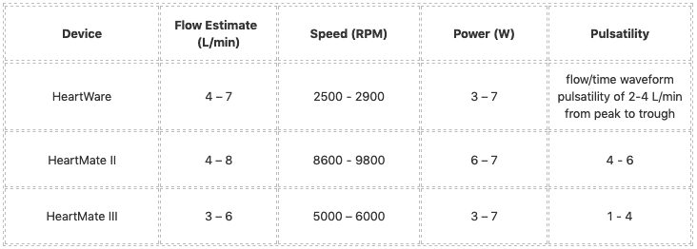
https://litfl.com/ventricular-assist-device-vad/

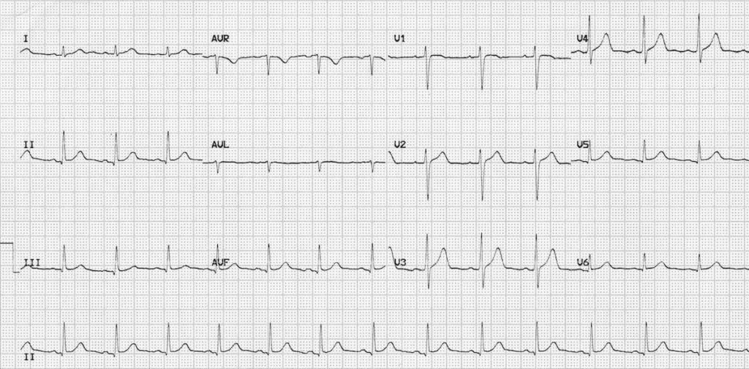
https://litfl.com/normal-sinus-rhythm-ecg-library/

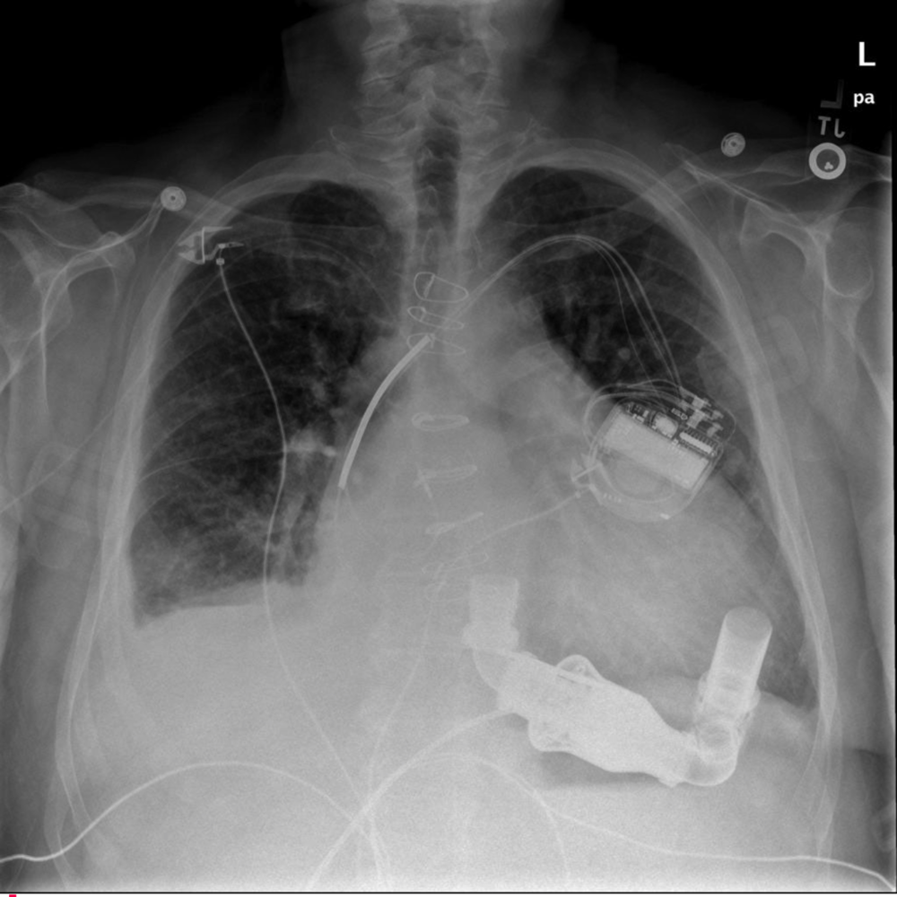
https://www.nuemblog.com/blog/lvad-management


https://www.pragueicu.com/echo-content/dilated-cardiomyopathy


https://www.grepmed.com/images/3905/lung-blines-pulmonary-clinical-pocus

Appendix C: Facilitator Cheat Sheet & Debriefing Tips

Include key errors to watch for and common challenges with the case. List issues expected to be part of the debriefing discussion. Supplemental information regarding any relevant pathophysiology, guidelines, or management information that may be reviewed during debriefing should be provided for facilitators to have as a reference.

Suggestions for the debrief:
- Most people are not familiar with LVAD’s. Instead of asking knowledge-based questions that may take away from focusing on CRM points that are really important in cases where we are unfamiliar, consider using directive feedback where you will almost always have a clear knowledge gap and you can use this opportunity to close that gap. When the first “well I’m not familiar the LVAD’s” occurs, ask if anyone is, and when everyone presumably says no, you can offer them a quick spiel on LVAD’s to then move on to CRM points such as: “Now that we know about LVAD’s , I noticed we were struggling to get a BP and while this presentation is unique, this issue is not, so I wonder what resources we have when we are unable to get a BP” - “I am certainly not familiar with LVAD’s (normalize), but now that we’ve talked about a few points, in hindsight, what would have been the best way to call for help or find information?. Explore calling for help, off-loading this” - “I noticed we were really focused on being unsure what an LVAD is, or how to manage it and sometimes being this unfamiliar can take away from our typical approach to patients. How do we make sure we are regrouping and not getting distracted by the nuanced of a unique presentation”
- Consider using this case in a repeat fashion. Run it once, discuss/debrief, then put into practice by running it again.

What is an LVAD and why might a patient have one?
- Left ventricular assist devices mechanically pump blood from the left ventricle into the aorta
- Consists of a pump implanted in the chest cavity. An inflow cannula delivers blood from the left ventricular apex to the pump, while an outflow cannula redelivers blood into the aorta.
- Used in patients who have severe congestive heart failure refractory to other treatment
- Can be implanted as bridge-to-transplant or destination therapy

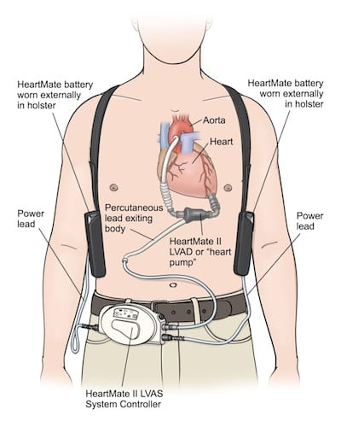
https://rebelem.com/left-ventricular-assist-device/

What are the potential complications of LVADs?
- Complications can be categorized as complications related to the pump, to the heart, and to other organs.
- Pump-related: pump thrombosis, suction events, mechanical failure
- Pump thrombosis: Can be due to spontaneous clot formation (“red clot”) or fibrin accumulation due to heat generated from the pump (“white clot”). Patients are often on antiplatelet and anticoagulation to prevent this.
- Suction Event: Transient collapse LV due to hypovolemia and suction created by pump
- Mechanical failure: dislodging or fracture of LVAD components
- Cardiac: ventricular arrhythmias, right ventricular failure
- Ventricular arrhythmias: LVAD implantation increases risk of ventricular arrhythmias. ICD is often placed simultaneously to address this complication.
- RV failure: May occur due to progressive dysfunction as LVAD does not support the RV. Normal LVAD function is also thought to alter RV physiology
- Non-Cardiac: stroke (both ischemic and hemorrhagic), GI bleed, infection/sepsis
- Stroke: Clots from pump thrombosis can cause ischemic stroke. AVM formation from non-pulsatile flow and antiplatelet/anticoagulation increase risk of hemorrhagic stroke
- GI Bleed: Due to AVM formation and antiplatelet/anticoagulation therapy
- Infection/sepsis: Infection of LVAD device leading to mediastinitis or endocarditis. Percutaneous insertion site of driveline may become infected.

What is the initial management of a patient presenting with a potential LVAD-related complication in the ER?
- Steps to considered can be recalled with the mnemonic ALIEVER
- ABCs
- Labs: CBC, CMP, troponin, BNP, LDH, haptoglobin, direct bilirubin, caogs (patient will typically be on warfarin or another anticoagulant)
- Inspection: Inspect LVAD connections, parameters, alerts
- EKG: expected finding is normal sinus rhythm
- Vitals: including specialized measurement of BP or SBP
- Echo: may reveal evidence of decompensated failure, whether left or right sided, or biventricular
- Radiology: consider chest x-ray and CT (may reveal pump thrombosis, infection, PE, etc.)

How should blood pressure be assessed in a patient with an LVAD?
- This will depend on whether the patient has a pulse at baseline, which the patient will typically know
- For patients with a pulse at baseline, blood pressure measurement can be performed as usual
- For patients without a pulse at baseline, the patient’s MAP is measured with doppler or arterial line
- Place the doppler probe over the pulse until a continuous whirring is heard
- Apply a blood pressure cuff to the arm and inflate until the whirring is no longer audible
- Slowly release the cuff until whirring is again heard, the pressure at which this happens is the patient’s MAP
- Normal MAP in an LVAD patient should be 70-90 mmHg
- Video demonstration: https://www.youtube.com/watch?v=FtHxlCFxB80

How should an LVAD be inspected?
- Connections:
- The drive line exiting the abdominal wall should be connected to the controller
- Two power lines should connect to batteries on either side of the carrier bag
- Controller for Heartmeate II and III:
- Battery level can be checked by pressing the battery button
- Pump parameters can be reviewed by successively pressing the rectangular screen button
- Alert logs can be reviewed by simultaneously pressing the silence button and rectangular screen button
- Video demonstration: https://www.youtube.com/watch?v=qm-zRtWj9Cw&t=460s

What are the parameters on an LVAD and what do they mean?
- The four parameters are speed of the motor (rpm), power used to by the machine to achieve the set speed (watts), pulsatility index (how pulsatile flow through the machine is), and flow through the machine (L/min)
- IMPORTANT: speed is set, power is measured, and pulsatility and flow are calculated (NOT directly measured)
- Normal ranges will depend on the specific device model (See Appendix B)

What potential resources are available to ED physicians when managing a patient with an LVAD?
- Cardiothoracic surgery: specialists who implant LVADs and treat complications
- LVAD team: centers that place LVADs often have in-house teams of LVAD coordinators who specially trained nurses who provide patient education and 24/7 call to assist others take care of LVAD patients

What clinical features are concerning for pump thrombosis?
- Clinical features including evidence of fluid overload and hemolysis (i.e., icterus, jaundice, hematuria).
- Notably, severity can range anywhere from asymptomatic to cardiac arrest depending on size and location of the thrombosis
- LVAD parameters: review of parameters will show high power and low flow
- Cardiac auscultation: “crunching” or “ice in a blender” sounds instead of normal “whirring”
- ECHO: biventricular enlargement and reduced EF

How is LVAD pump thrombosis diagnosed?
- High clinical suspicion with new onset of CHF symptoms and evidence of hemolysis on exam or laboratory evaluation warrant further investigation and possibly empiric anticoagulation
- May be visualized on CT angiogram, however, sensitivity has been shown in small studies to be low
- Gold standard diagnostic test is surgical exploration of pump and direct visualization of thrombosis

What is the treatment and disposition of a patient with an LVAD pump thrombosis?
- Anticoagulation is often used as first line treatment in hemodynamically stable patients
- Systemic fibrinolysis may be considered in unstable patients
- Thrombosed pumps may ultimately need to be surgically repaired or replaced
- Should be admitted to CTICU or SICU under care of the care of a cardiothoracic surgeon

References
- Blitz A. Pump thrombosis-A riddle wrapped in a mystery inside an enigma. Ann Cardiothorac Surg. 2014;3(5):450-471
- Long B, Robertson J, Koyfman A, Brady W. Left ventricular assist devices and their complications: A review for emergency clinicians. Am J Emerg Med. 2019;37(8):1562-1570.
- Robertson J, Long B, Koyfman A. The emergency management of ventricular assist devices. Am J Emerg Med. 2016;34(7):1294-1301.
- Shroff GS, Ocazionez D, Akkanti B, et al. Ct imaging of complications associated with continuous-flow left ventricular assist devices(Lvads). Semin Ultrasound CT MR. 2017;38(6):616-628.
- Trinquero P, Pirotte A, Gallagher LP, Iwaki KM, Beach C, Wilcox JE. Left ventricular assist device management in the emergency department. West J Emerg Med. 2018;19(5):834-841.

